Security in Computing Practical 7
Layer 2 Security Configuration
Practical 7: Layer 2 Security
Topology:

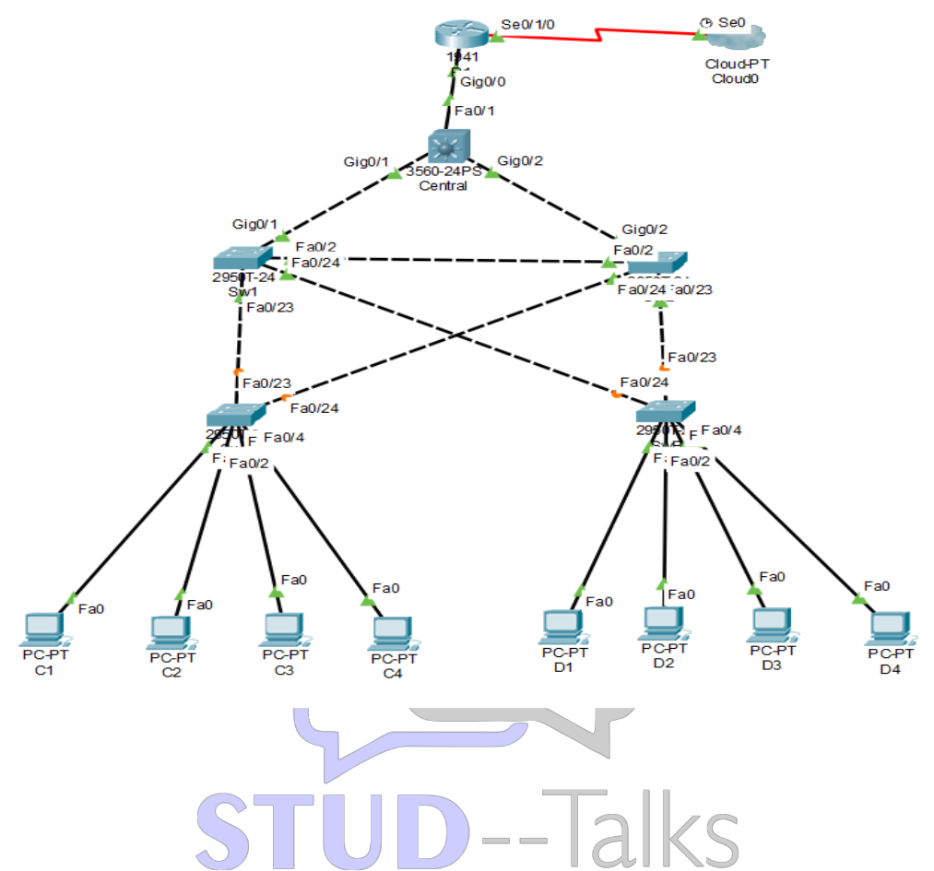

Basic Configuration (Router & Switches)
enable
conf t
enable secret enpa55
line console 0
password conpa55
login
exit
ip domain-name ccnasecurity.com
username admin secret adminpa55
line vty 0 4
login local
transport input ssh
exit
crypto key generate rsa
1024
end
wr

Root Bridge Configuration
! On Central Switch
conf t
spanning-tree vlan 1 root primary
end
! On SW1
conf t
spanning-tree vlan 1 root secondary
end

STP Security Configuration
! Enable PortFast
interface range fa0/1 - 4
spanning-tree portfast
exit
! Enable BPDU Guard
interface range fa0/1 - 4
spanning-tree bpduguard enable
exit
! Enable Root Guard
interface range fa0/23 - 24
spanning-tree guard root
exit

Port Security Configuration
interface range fa0/1 - 22
switchport mode access
switchport port-security
switchport port-security maximum 2
switchport port-security violation shutdown
switchport port-security mac-address sticky
exit
! Disable unused ports
interface range fa0/5 - 22
shutdown
exit

Verification Steps
1. show spanning-tree
2. show port-security interface fa0/1
3. Test:
Ping between PCs (should work)
4. Check:
- Root bridge is Central
- PortFast enabled
- BPDU guard active
- Port security working
Practical 7: Layer 2 Security
- On Central Switch & SW1:
  - show spanning-tree: To verify the Root Bridge and that PortFast is enabled on access ports.
  - show port-security interface fa0/1: To verify the maximum MAC addresses (2) and that the violation mode is set to "shutdown".
  - show port-security address: To see the "sticky" MAC addresses learned by the switch.

Practical 7: Layer 2 Security
On Central Switch
- Root Bridge: Run show spanning-tree to verify it says "This bridge is the root".
On Switches SW-A/B
- Port Security: Run show port-security interface fa0/1. Verify "Violation Mode: Shutdown" and "Sticky MAC Addresses".

Viva Questions
1. What is STP?
Prevents loops in network.
2. What is Root Bridge?
Main switch controlling STP.
3. What is Port Security?
Limits MAC addresses on port.
4. What is BPDU Guard?
Prevents unauthorized switches.
5. What is PortFast?
Speeds up port activation.

